Office Hours Mon: 8:30am-6:00pm, Tues, Wed, Thurs: 8:30am-4:30pm, Fri 8:30am-12:30pm

MEMBERS OF COUNCIL:
John Wise (Reeve): 613-378-2583
Douglas Davison (Deputy Reeve): 613-377-6420
Wenda Lalande (Councillor): 613-453-2149
Rob Fenwick (Councillor): 613-539-1492
Krysta-Lee Woodcock (Councillor): 613-885-9448
Shari Milligan (Councillor): 613-449-1926
Wendy McDonald (Councillor): 613-329-0597

2024 Budget

On March 4th, 2024, the Township of Stone Mills approved a 2024 budget totalling $15,593,625.95. The Municipal portion to be raised through property taxation is $6,737,557.68. In order to raise this amount, the Township of Stone Mills residential tax levy will increase by 2.8%. It is the Township’s responsibility to levy on behalf of the County of Lennox and Addington and the Ministry of Education. The County’s Levy is $5,796,984.32 and the Education Levy is $1,710,319.49.

The average residential household assessment in 2024 was $218,000.00. The 2024 average assessment remains unchanged due to the Municipal Property Assessment Corporation (MPAC) deferring property assessments due to COVID-19. Based on this information, a household with a $218,000.00 assessment would expect an increase of $39.89 for their municipal portion of taxes. When the County and education levies are included, the average household increase will be approximately $75.01.

Allocation of Stone Mills tax dollars based on $100,000 of assessment

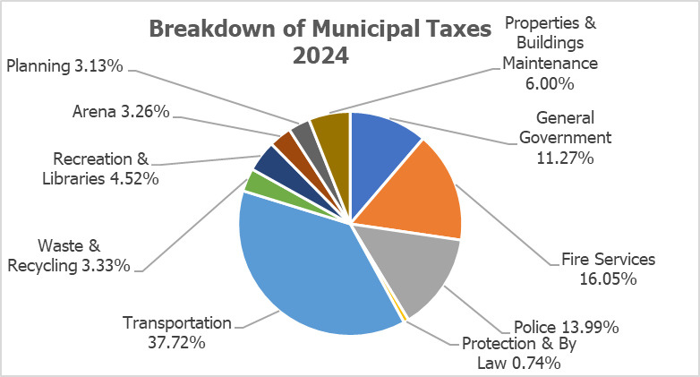

Allocation of Stone Mills Tax dollars | 100,000.00 Assessment
General Government | $ 75.62
Fire Services | $107.73
Police | $ 93.90
Protection & By law | $ 4.96
Transportation | $253.23
Waste & Recycling | $ 22.34
Recreation & Libraries | $ 30.34
Arena | $ 21.89
Planning | $ 20.99
Properties & Building Maintenance | $ 40.25
Total | $671.25
Total Residential Tax Rate | Assessment | Total Taxes
0.01403822 | 100,000 | $ 1,403.82
County | 41.29% | $ 579.58
Education | 10.90% | $ 153.00
Township | 47.82% | $ 671.25

Council: The Township of Stone Mills Council meets twice a month to consider decisions that affect the corporation as a whole. Information, meeting dates and times are publicly available on the Township’s website. Council is pleased to announce the hiring of Jason White as the Townships new Chief Administrative Officer (CAO) effective June 13, 2024.

Fire: The Stone Mills Fire Department (SMFD) completed the assembly of a new Quick Response Rescue for Station 4 (Tamworth) to replace the existing 1989 Rescue 741. New Self-Contained Breathing Apparatus (SCBA) will be purchased in 2024. The new SCBA’s will replace the existing 32 SCBA’s that are at the end of their 15-year life. The 1995 Utility 741 at Station 4 – Tamworth will be replaced with a new 2024 ¾ ton pickup truck. Replacement Auto Extrication tools were purchased for Station 3 – Newburgh in early 2024. This purchase was fully funded by the Firehouse Subs Public Safety Foundation of Canada.

10 new Firefighter Recruits will join the department in 2024 after training to meet NFPA standards. Stone Mills has approximately 100 active volunteer firefighters throughout the Township. In 2023 Stone Mills Fire Department responded to 174 calls for service. We remind all residents to ensure they have a working smoke and carbon dioxide (CO) alarms and a home escape plan.

Development Services: The Township of Stone Mills Development Services department is working through the background study supporting the potential adoption and implementation of Development Charges. From a policy and regulatory perspective, public comments considering potential changes to land use planning controls applicable to lands comprised of Class 1-3 soils (Canada Land Inventory) are being contemplated.

The department continues to work in partnership with the County of Lennox & Addington through the implementation of the Development Approvals Process (DAP) which will modernize the approvals process in both Planning and Building Services. CityWorks is scheduled to be activated within all lower tier municipalities in the County of Lennox & Addington with an initial focus on Planning Act applications.

Policing: The Township of Stone Mills collaboratively participates in a Policing Agreement as part of a Lennox & Addington (L&A) Detachment Board.

Roads: The 2024 approved budget will include two Tandem Plow Trucks, one-ton Crew Cab and a ½ ton patrol truck. Capital roads projects are now underway in Tamworth with the reconstruction of Peel Street, Mill Pond Drive and a portion of Addington Street. Yearly maintenance includes grading, dust control, brushing/grass mowing, line painting sidewalks and winter control. The Municipality (lower tier) receives $1,030,400 from the County of Lennox & Addington (upper tier) for maintenance on the 162 kilometers of County Roads in the Township.
Waste & Recycling: The Township has three (3) landfill sites, Camden East: 3087 County Road 4, Moscow: 4965 County Road 6 and Tamworth: 1661 County Road 15. Hours of operation are Wednesday’s 12:00pm – 4:00pm and Saturday’s 8:00am – 4:00pm. To promote the longevity of our landfills, we encourage residents to help us increase our recycling efforts. Effective May 1st garbage bags increased to $3.00 per bag. For information on what can be recycled, please visit the Township’s website.

Recreation: Swimming lessons for all ages are available at Beaver Lake during July & August 2024. Visit the Beaver Lake Swim Program on Facebook for further details. Indoor pickleball is available throughout the summer at the Stone Mills Recreation Centre: Mondays, Wednesdays Saturdays: 10am – 12pm and Tuesdays, Thursdays: 7:00pm – 9:00pm. The Township’s skatepark is located at 16 Railway St, directly beside the Tamworth Soccer Field. A public open space (parkette) will be completed in fall 2024 at the southeast corner of the County Road 1 & County Road 4 intersection in Camden East, location of the former Camden East Library and Daycare. The Township will be seeking public comment respecting proposed upgrades to the Yarker Riverside Park. As it relates to the Enterprise Community Hall, the Township will be completing upgrades to the accessibility ramp providing access to the landmark building.

For ice rental bookings, please contact the Recreation Centre at 613-379-2349. To book a hall please contact the main office at 613-378-2475. COMING SOON is a new recreation and hall booking web-based software that will be launched this summer.

